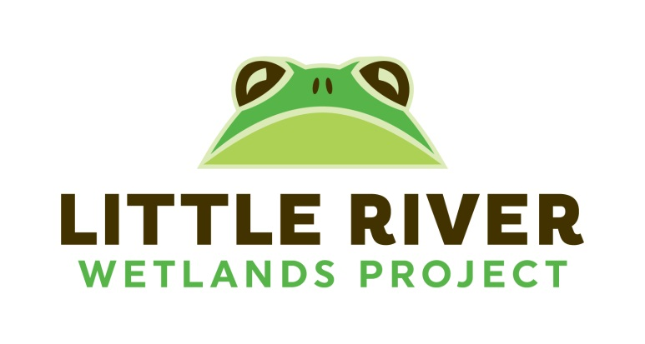
Volunteer Time Sheet
Due November 1, _____
Name:_________________

Date | Stewardship | Citizen Science | Education | Office | Large Events | Totals

